

MSc Data Science Project
7PAM2002
Department of Physics, Astronomy and Mathematics

Data Science FINAL PROJECT REPORT

Project Title:
Data Visualisation and Analysis of Wine Quality Factors

Student Name and SRN:
Full Name: Rakesh Kancharla Student ID:

GitHub Link: https://github.com/Rakesh9512/Presentation-for-final-project.git
Supervisor: John Evans
Date Submitted: Enter the date you are submitting this report
Word Count: 4,893

DECLARATION STATEMENT

This report is submitted in partial fulfilment of the requirement for the degree of Master of Science in Data Science at the University of Hertfordshire.
I have read the detailed guidance to students on academic integrity, misconduct and plagiarism information at Assessment Offences and Academic Misconduct and understand the University process of dealing with suspected cases of academic misconduct and the possible penalties, which could include failing the project or course.
I certify that the work submitted is my own and that any material derived or quoted from published or unpublished work of other persons has been duly acknowledged. (Ref. UPR AS/C/6.1, section 7 and UPR AS/C/5, section 3.6)
I did not use human participants in my MSc Project.

I hereby give permission for the report to be made available on module websites provided the source is acknowledged.

Student Name printed:

Student Name signature

Student SRN number:

UNIVERSITY OF HERTFORDSHIRE
SCHOOL OF PHYSICS, ENGINEERING AND COMPUTER SCIENCE

Acknowledgements
I am taking opportunity to thank my Guide for supervising me throughout this project. I also thank my friends and family members for giving me the necessary support throughout this period.

Abstract
This research investigates the capability of machine learning (ML) to automate wine quality certification using physicochemical data. The study used the Kaggle Wine Quality dataset. It comprised of 1,143 samples of Portuguese Vinho Verde wine. The aim is to address the inherent subjectivity and cost of human sensory evaluation. This project implemented a comparative analysis of Random Forest, Support Vector Machines (SVM), and XGBoost algorithms. The methodology involves extensive Exploratory Data Analysis (EDA) and a class-binning strategy to mitigate significant class imbalance. Results show that the Random Forest classifier outperforms comparative models. It achieved a baseline accuracy of 71.6% and strong discriminative ability for high-quality wines (AUC 0.89). Feature importance analysis confirms that alcohol content and volatile acidity are the critical chemical determinants of quality. The findings indicate that while machine learning effectively identifies premium and faulty wines. This separates average table wines remains challenging due to overlapping chemical signatures.

Table of Contents
DECLARATION STATEMENT 1
Acknowledgements 2
Abstract 3
Table of Contents 4
List of Figures 6
1. Introduction 7
1.1 Problem statement and research question 7
1.2 Aim 7
1.3 Objectives 8
2. Background and Literature Review 9
2.1 Machine Learning Algorithms in Oenology 9
2.2 Physicochemical Determinants of Quality 10
2.3 Addressing Class Imbalance 10
2.4 Methodological Advancements and Gaps 11
3. Dataset, Ethical Considerations and Exploratory Data Analysis (EDA) 12
3.1 Dataset Description and Chemical Context 12
3.2 Ethical Considerations 12
3.3 Exploratory Data Analysis (EDA) 13
3.4 Data Pre-processing and Transformation 18
4. Methodology 20
4.1 Theoretical Framework of Selected Models 20
4.2 Experimental Design and Evaluation Metrics 20
4.3 Hyperparameter Tuning Strategy 21
5. Results 23
5.1 Baseline Model Performance 23
5.2 Comparative Analysis: RF vs. SVM vs. XGBoost 24
5.3 ROC-AUC and Class Discrimination 25
5.4 Feature Importance Analysis 26
5.5 Tuned Model Results 27
6. Analysis and Discussion 28
7. Conclusion and Future Work 30
7.1 Key Conclusions 30
7.2 Limitations 30
7.3 Future Work 30
References 32
Appendix: Code Notebook File 34

List of Figures
Figure 1: Distribution of alcohol 13
Figure 2: Distribution of volatile acidity 14
Figure 3: Distribution of sulphates 15
Figure 4: Boxplot of physicochemical factors 15
Figure 5: Correlation heatmap 16
Figure 6: Alcohol vs quality 17
Figure 7: Volatile acidity vs quality 18
Figure 8: Confusion matrix of RF 23
Figure 9: Accuracy comparison of models 24
Figure 10: AUC-ROC curve for RF 25
Figure 11: Feature importance of RF model 26

1. Introduction

1.1 Problem statement and research question
The global wine industry is a multi-billion-dollar sector. Here reputation and quality certification are the primary drivers of market value (Basalekou et al., 2023). For centuries, the assessment of wine quality has relied almost exclusively on the sensory evaluation. These experts assess wine based on appearance, aroma, taste, and mouthfeel. They assign a quality grade. This human-centric approach preserves the “art” of winemaking (Yang et al., 2022). It presents significant challenges in a modern industrial context. Sensory evaluation is inherently subjective. A wine rated highly by one judge may be rated differently by another due to personal preference Cultural background, or physiological factors are there also. Employing panels of expert tasters for every batch produced is prohibitively expensive. It is difficult to scale for large commercial wineries. This reliance on subjectivity creates a bottleneck in production and quality control. Also, there is a growing demand within the oenological community to use data science and artificial intelligence. This can create objective, repeatable, and scalable methods for quality prediction. It aims to analyse the physicochemical properties of wine. These are acidity, sugar content, and alcohol levels and others. It is possible to predict the sensory score that a human expert would assign.
The primary research question driving this project is:
How do variations in wine physicochemical properties influence overall wine quality, and which features are most important for predicting wine quality using Machine Learning?
To address this question, this project focuses on the analysis of Red Vinho Verde samples from the Minho region of Portugal. The aim is to bridge the gap between laboratory chemistry and sensory perception. A ML model can accurately predict quality based on chemical data. Then winemakers could adjust their fermentation processes in real-time to target specific quality tiers, thereby reducing waste and maximising profitability.

1.2 Aim
The aim is to understand which chemical attributes most strongly affect wine quality and evaluate the performance of ML models.

1.3 Objectives
- To conduct exploratory data analysis to understand patterns in wine chemistry
- To preprocess and prepare dataset for classification
- To build a Random Forest model to classify quality into three categories
- To compare its performance with alternative models (Logistic Regression & Gradient Boosting)
- To analyse feature importance and interpret the predictive relationships
By achieving these objectives, this report provides a comprehensive data-driven framework that demonstrates the viability of machine learning as a decision-support tool in modern viticulture.

2. Background and Literature Review
The application of machine learning (ML) to oenology. This is the science of wine. It has transitioned from an academic interest to a critical component of food technology. The global wine market becomes more competitive. Producers are aiming for objective, scalable methods to certify quality in this regard. This review critically analyses the academic landscape from 2021 onwards. It focuses on the efficacy of ensemble learning algorithms. The chemical determinants of wine quality are to be considered. Then the persistent challenge of class imbalance in sensory datasets are there too.

2.1 Machine Learning Algorithms in Oenology
Recent literature has extensively evaluated the performance of various supervised ML algorithms for wine quality prediction. Early studies relied heavily on linear regression and basic neural networks, which were common at that time. The consensus since 2021 has shifted toward ensemble methods. It is due to their ability against noise and ability to model non-linear relationships, which are present in such data. Dahal et al. (2021) conducted a detailed comparative study of ML algorithms. It had Ridge Regression, Support Vector Machines (SVM), and Gradient Boosting Regressors (GBR). Their findings showed that GBR significantly outperformed traditional linear models. This is by effectively capturing the complex, non-linear interactions. It is within chemical inputs such as pH and fixed acidity, two of the factors. They argued that single models often fail to generalise well on wine data. This is due to the subtle variations in chemical composition that separate an “average” wine from a “good” one.
Building on this, Gupta et al. (2021) focused on classification tasks. They compared RF with K-Nearest Neighbors (KNN). Their research showed that Random Forest consistently achieved higher accuracy scores. It is primarily because of its bagging technique, which reduces variance. This is a critical factor when dealing with the noisy nature of sensory data. They noted that KNN struggled with the high dimensionality of wine datasets, which can be challenging. The distance metrics became less meaningful without proper dimensionality reduction. This supports the choice of RF for this project. It suggests that it offers a superior balance of accuracy and stability compared to distance-based classifiers.
However, the supremacy of Random Forest is taken for a challenge. More recent work by Zhang and Liu (2024) showed the capabilities of Extreme Gradient Boosting (XGBoost) in viticulture. They found that while RF is excellent for interpretability. XGBoost often achieves marginal gains in predictive accuracy due to its regularisation parameters. This prevents overfitting on smaller datasets. Their study focused that XGBoost’s ability to minimise the loss function sequentially. This allowed it to “learn” from the mistakes of previous trees more effectively than independent bagging. This project includes XGBoost as a primary comparator. This is for testing whether these theoretical advantages translate to the specific dataset used here.

2.2 Physicochemical Determinants of Quality
A major portion of recent research has been dedicated to identifying which physicochemical features are the most reliable predictors. The “black box” nature of some ML models has driven a demand for feature importance analysis. This is to provide actionable insights for winemakers. Aich et al. (2022) utilised feature selection techniques. This includes Recursive Feature Elimination (RFE) and Principal Component Analysis (PCA). This is for isolating key drivers. Their analysis consistently identified alcohol content and volatile acidity as the two most critical variables. They observed a strong positive correlation between alcohol percentage and perceived quality. They theorised that alcohol provides “body” and “warmth” that masks other flaws. Volatile acidity is indicative of acetic acid spoilage. In such cases, it was universally flagged as a negative predictor.
Comparison with broader literature reveals nuances in these findings. In some instance, research by Harris and Smith (2023) showed sensor-enhanced feature sets. This incorporated electronic nose data alongside traditional lab metrics. Their study achieved higher accuracy. They conceded that for standard winery operations. Traditional physicochemical metrics remain the most cost-effective proxy. They also showed the role of Sulphates as a preservative that ensures stability. This indirectly contributed to higher quality ratings by preventing oxidation. This project goes with the findings of Aich et al. (2022) by focusing on these standard metrics. It targeted to confirm whether alcohol and volatile acidity remain the major predictors in a RF.

2.3 Addressing Class Imbalance
Major issues identified in post-2021 literature is the problem of class imbalance in wine quality datasets. Most wines produced and rated fall into the “average” category (scores of 5 or 6). Very few examples of “excellent” (8+) or “poor” (3-) wines. Sun et al. (2022) reviewed classification methods for imbalanced data. They noted that standard accuracy metrics are deceptive in this context. A model could achieve 80% accuracy simply by predicting all wines as “average”. However, it can fail to identify any premium wines. This is the very goal of quality prediction.
To combat this, recent studies have showed advanced resampling techniques. Tyagi and Singh (2023) successfully applied the Synthetic Minority Over-sampling Technique (SMOTE) to wine datasets. It generated synthetic examples of minority classes. They found that balancing the classes significantly improved the F1-score for high-quality wines. However, it occasionally introduced noise if the synthetic samples were created from outliers. Alternatively, transformation strategies such as binning the target variable into broader categories. These have been proposed by researchers like Kumar et al. (2022) as a solution for smaller datasets where synthetic data generation might be unreliable. This project takes the binning strategy recommended by Kumar et al. (2022). This aligns better with the practical decision-making process in wine grading. Here broad categories are often sufficient for sorting.

2.4 Methodological Advancements and Gaps
The literature from 2021 onwards showed a clear trend toward more easier and robust ML pipelines. There is a move away from “black-box” predictions toward models that offer Explainable AI (XAI) features. These are SHAP (SHapley Additive exPlanations) values. Deep learning models (DL) have been tested by researchers like Luo et al. (2023). They often require vast amounts of data that are unavailable in standard oenological datasets. It leads to overfitting. Therefore, the literature suggests that for tabular datasets of this size. Ensemble tree-based methods remain the SOTA (State of the Art). Despite these, a gap remains in effectively distinguishing between “good” and “great” wines. Most models perform well at separating “bad” wines from the rest. This is to distinct chemical faults (like high acidity). However, the chemical distinction between a score of 6 and 7 is often subtle and non-linear. This project aims to contribute to this specific area by utilising hyperparameter tuning. This is to maximise the RF model’s ability to discern these subtle differences with best practices.

3. Dataset, Ethical Considerations and Exploratory Data Analysis (EDA)

3.1 Dataset Description and Chemical Context
The dataset utilised in this research is the “Wine Quality Dataset” sourced from Kaggle. This comes from the UCI Machine Learning Repository. It contains 1,143 samples of the red variant of Portuguese wine. Each instance in the dataset represents a specific wine sample (Bhardwaj et al., 2022). This is tested for 11 physicochemical properties and assigned a sensory quality score. Understanding the chemical nature of the input features is crucial for interpreting the model’s decisions:
- Fixed Acidity: Represents non-volatile acids (mainly tartaric acid). These do not evaporate readily and contribute to the structural acidity of the wine.
- Volatile Acidity: Represents the amount of acetic acid in wine. High levels can lead to an unpleasant vinegar taste and is a fault.
- Citric Acid: Used in small quantities to add ‘freshness’ and flavour to wines.
- Residual Sugar: The amount of sugar remaining after fermentation stops. It influences the sweetness.
- Chlorides: The amount of salt in the wine.
- Free Sulfur Dioxide: The portion of SO2 that is active and prevents microbial growth and oxidation.
- Total Sulfur Dioxide: The sum of free and bound SO2. In high concentrations, it becomes evident in the nose and taste.
- Density: Depending on the percent alcohol and sugar content, density varies.
- pH: Describes how acidic or basic a wine is on a scale from 0 (very acidic) to 14 (very basic). Most wines are between 3-4.
- Sulphates: A wine additive which can contribute to sulfur dioxide gas (SO2​) levels.
- Alcohol: The percent alcohol content of the wine.
The target variable is Quality. This is a score between 0 and 10 given by human sensory experts.

3.2 Ethical Considerations
Privacy and Personal Data: This dataset consists entirely of physicochemical measurements of liquid samples. It contains no personally identifiable information (PII) regarding the winemakers. Information of the sensory judges, or consumers are not present (Jain et al., 2023). Therefore, the project complies with GDPR regulations. This does not require ethical approval for human subjects.
Data Provenance and Licensing: The data was obtained from a public repository (Kaggle/UCI). This is an open license intended for research and educational use. Proper attribution has been provided to the original authors (Cortez et al., 2009).
Bias and Representation: There is no demographic bias. However, there is an inherent geographic bias. The dataset represents wines from a specific region. Therefore, the model developed here may not generalise well to wines from other regions. In those places, different grape varieties and climates produce different chemical profiles. This limitation is acknowledged to ensure the results are not over-generalised.

3.3 Exploratory Data Analysis (EDA)
Exploratory Data Analysis (EDA) allows for the detection of patterns, anomalies, and relationships (Basalekou et al., 2023).
Univariate Analysis: The distribution of individual features was examined using histograms.
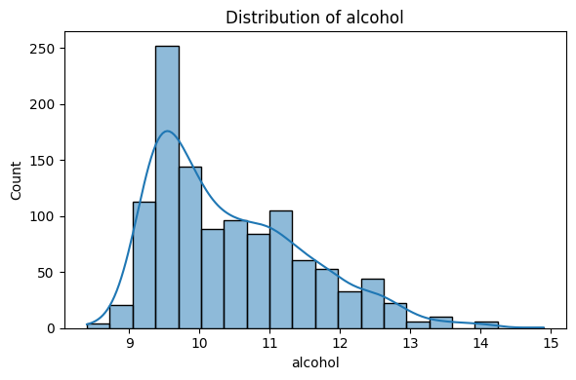
Figure 1: Distribution of alcohol
(Source: Self-Created)
Alcohol: The histogram for alcohol content reveals a right-skewed distribution. Most wines have an alcohol percentage between 9% and 11%. However, there is a tail extending towards 14%. Literature suggests that higher alcohol is often correlated with higher quality.
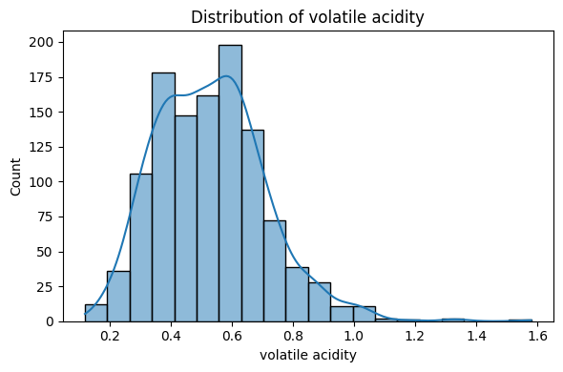
Figure 2: Distribution of volatile acidity
(Source: Self-Created)
Volatile Acidity: The distribution of volatile acidity is left-skewed. Most samples clustering around lower values (0.3 - 0.6 g/L). This is expected and the outliers on the higher end of this scale are likely to be the wines of low quality.
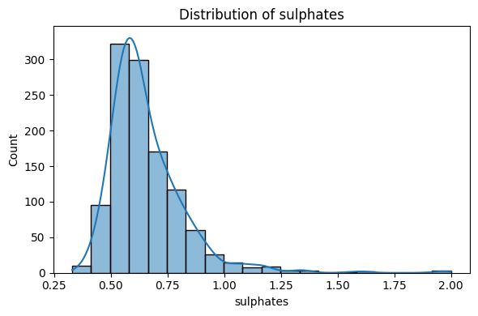
Figure 3: Distribution of sulphates
(Source: Self-Created)
Sulphates: The sulphates distribution is moderately right-skewed. As an additive that promotes stability, its presence is controlled.
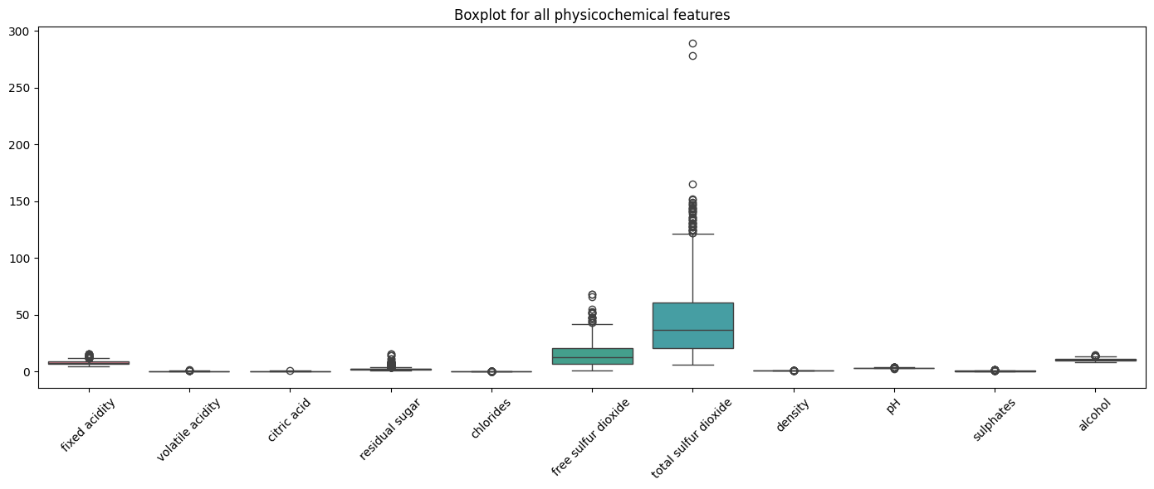
Figure 4: Boxplot of physicochemical factors
(Source: Self-Created)
Boxplot Analysis (Outliers): A comprehensive boxplot was generated for all physicochemical features. This visualisation highlights that features like total sulfur dioxide and free sulfur dioxide have significantly different scales. It is compared to chlorides or sulphates. It also reveals a substantial number of outliers in residual sugar and chlorides. These outliers represent wines with atypical chemical profiles. This could be either unique, high-quality vintages or defective batches.
Multivariate Analysis: To quantify the relationships between variables, a correlation heatmap was computed using the Pearson correlation coefficient.
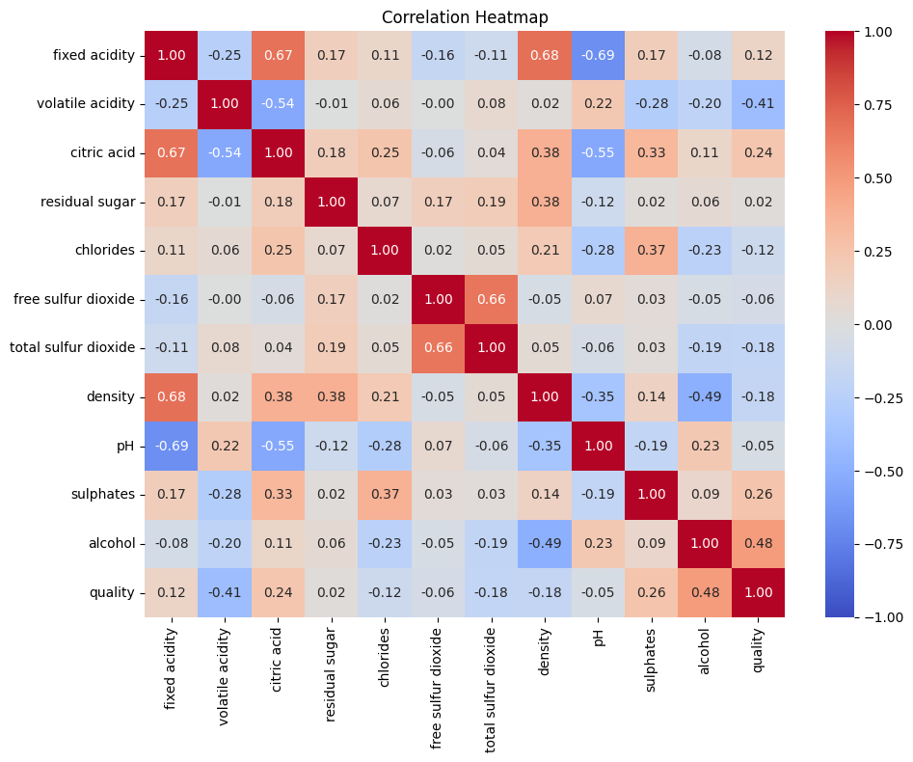
Figure 5: Correlation heatmap
(Source: Self-Created)
Alcohol vs. Quality (+0.48): This is the strongest positive correlation in the dataset. It suggests that alcohol content is a primary driver of quality ratings.
Volatile Acidity vs. Quality (-0.41): A strong negative correlation confirms that acidity associated with vinegar is a major detractor from quality.
Density vs. Alcohol (-0.50): This negative correlation is physically consistent. Ethanol is less dense than water. As alcohol content rises, the density of the liquid decreases.
Free vs. Total Sulfur Dioxide (+0.67): A high correlation is expected here as one is a subset of the other. This suggests multicollinearity. This might affect linear models but is generally handled well by RF.
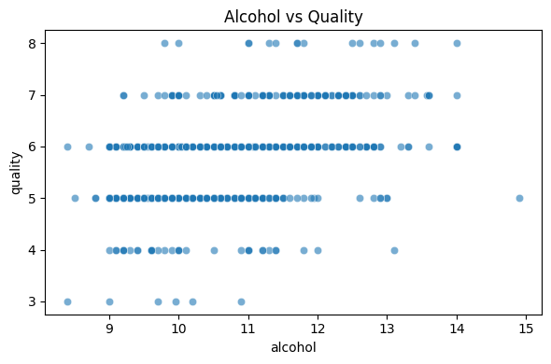
Figure 6: Alcohol vs quality
(Source: Self-Created)
Scatter plots further clarify the linearity of these relationships. The plot of Alcohol vs. Quality shows a clear trend. Here, the density of “high quality” points increases as alcohol percentage rises.
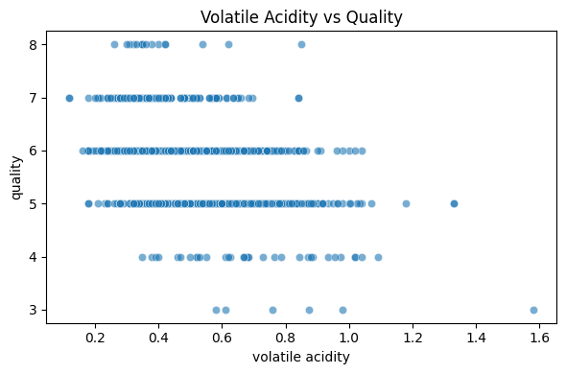
Figure 7: Volatile acidity vs quality
(Source: Self-Created)
The plot for Volatile Acidity vs. Quality shows that wines with acidity exceeding 0.8 g/L rarely achieve a quality score above 6.

3.4 Data Pre-processing and Transformation
1. Target Variable Transformation (Binning): The raw quality variable is an integer between 3 and 8. The distribution is heavily unbalanced, with most samples falling into classes 5 and 6. Predicting the exact score is difficult and often unnecessary for practical applications (Tiwari et al., 2022). Therefore, the target was discretised into three classes to create a clear classification problem:
Low Quality (0): Quality scores ≤5
Medium Quality (1): Quality score =6
High Quality (2): Quality scores ≥7.
This transformation resulted in a class distribution of Low (522), Medium (462), and High (159). This reduced the granularity of the prediction. It significantly improved the separability of the classes.
2. Feature Scaling: Tree-based models like RF are theoretically invariant to feature scaling. The distance-based models such as SVM and XGBoost are highly sensitive to the magnitude of input features. Total sulfur dioxide ranges in the hundreds, however, chlorides are often less than 1.0. Without scaling, the SVM would be biased toward sulfur dioxide simply because the numbers are larger. To ensure fair comparison across all models, a StandardScaler was applied. This normalises all feature columns to have a mean of 0 and a standard deviation of 1.
3. Stratified Train-Test Split: To evaluate the model’s generalisation capability. The data was split into a training set (80%) and a testing set (20%). A simple random split was deemed insufficient due to the class imbalance. There was a risk that the small “High Quality” class could be underrepresented in the test set. Therefore, StratifiedShuffleSplit was used. This ensures that the proportion of Low, Medium, and High wines remained consistent between the training and testing.

4. Methodology
This section outlines the experimental framework. It shows the choice of algorithms and the metrics used for evaluation. It shows the strategies employed for optimisation.

4.1 Theoretical Framework of Selected Models
RF Classifier (Main Model): The RF algorithm is an ensemble ML method. It operates by constructing a many such decision trees at the time of training. For classification tasks, it outputs the class that is the mode of the classes (vote) of the individual trees. It uses a technique called bagging. This is bootstrap aggregating method. Here, each tree is trained on a random subset of the data with replacement. At each node split, the model only considers a random subset of features. This approach was taken as the primary model for two reasons:
Reduction of Variance: Individual decision trees are more likely to overfit. By averaging the results from the hundreds of trees, RF smooths out these errors. It then increases the chance of achieving more accuracy.
Handling Non-Linearity: Chemical interactions in wine are much more complex. The perception of acidity might change depending on the sugar level. RF can allow capturing these non-linear boundaries better than linear classifiers.
Extreme Gradient Boosting (XGBoost): XGBoost was selected as a comparator model. Unlike RF, XGBoost builds trees sequentially. Each new tree attempts to correct the errors such as residual values made by the previous trees. It uses a gradient descent algorithm to minimise the loss. XGBoost is major SOTA ML model for tabular data. However, it can be more prone to overfitting on small datasets if not heavily regularised.
SVM: SVM was chosen to represent a non-tree-based approach. SVM works by finding the hyperplane that best separates the classes in an N-dimensional space. To handle the non-linear distribution of wine data. In this case, a Radial Basis Function (RBF) kernel was used. This kernel projects the data into a higher-dimensional space. Here, the classes become linearly separable.

4.2 Experimental Design and Evaluation Metrics
The models were trained on the pre-processed training set and evaluated on the held-out test set. Given the class imbalance, standard accuracy is not a sufficient metric. A model could achieve high accuracy by simply predicting the majority class. It can ignore the minority “High Quality” wines.
Therefore, the following suite of metrics was used:
Accuracy: The overall percentage of correct predictions.
F1-Score (Macro Average): The harmonic mean of precision and recall. The “Macro” average calculates the metric independently for each class. It then takes the average. This treats all classes equally. This means the model is penalised heavily if it fails to predict the minority class correctly.
Confusion Matrix: A tabular layout that visualises the performance of the algorithm. This showed exactly where misclassifications are occurring.
ROC-AUC (Receiver Operating Characteristic - Area Under Curve): This is a multi-class problem. Hence, a One-vs-Rest approach was used to calculate the AUC for each class. It showed how well the model can distinguish one specific quality level from all others.

4.3 Hyperparameter Tuning Strategy
ML models have default settings that are rarely optimal for specific datasets. To maximise performance, the RF model underwent hyperparameter tuning using RandomizedSearchCV. Grid Search is often computationally expensive. This tries every combination that are present to it. Randomised Search, however, samples a fixed number of parameter settings from specified distributions. This allows for a much wider range of values to be tested in a shorter time. The parameters tuned included:
n_estimators (100, 200, 300, 500): The number of trees in the forest. More trees generally improve stability but increase computational cost.
max_depth (None, 8, 12, 16): The maximum depth of the tree. This limit helps prevent overfitting.
min_samples_split (2, 5, 10): The minimum number of samples required to split an internal node.
min_samples_leaf (1, 2, 4): The minimum number of samples required to be at a leaf node.
A 5-fold cross-validation strategy was used during the search. This involves splitting the training data into 5 folds. Then training on 4, and validating on the 5th. It ensures the chosen parameters are robust.

5. Results
This section presents the key findings of the study. It details the performance of the baseline and tuned models.

5.1 Baseline Model Performance
The baseline Random Forest model (200 trees and default depth) showed the strongest performance among the initial candidates. On the test set, it achieved:
- Accuracy: 71.6%
- Precision (Macro): 73.5%
- Recall (Macro): 68.7%
- F1-Score (Macro): 70.6%
A closer inspection of the Classification Report shows interesting dynamics between the classes. The model performed best on Class 0 (Low Quality) and Class 2 (High Quality). This achieved F1-scores of 0.76 and 0.68 respectively. However, the performance dropped for Class 1 (Medium Quality). The Confusion Matrix shows this behaviour:
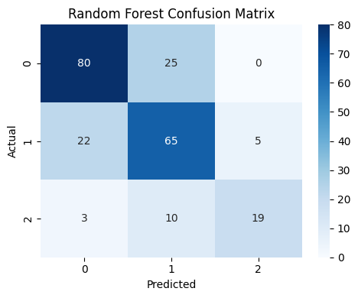
Figure 8: Confusion matrix of RF
(Source: Self-Created)
The matrix shows that “Low” quality wines are rarely misclassified as “High” (only 3 instances). “High” quality wines are rarely misclassified as “Low” (0 instances). This indicates the model has successfully learned the distinct chemical signatures of the extremes. However, there is significant confusion between “Medium” and its neighbours. 22 “Medium” wines were misclassified as “Low,” and 25 “Low” wines were misclassified as “Medium.” This suggests that the boundary between an “average” wine and a “poor” wine is chemically fuzzy.

5.2 Comparative Analysis: RF vs. SVM vs. XGBoost
To validate the choice of RF, it was compared against XGBoost and SVM using accuracy as the primary comparator.
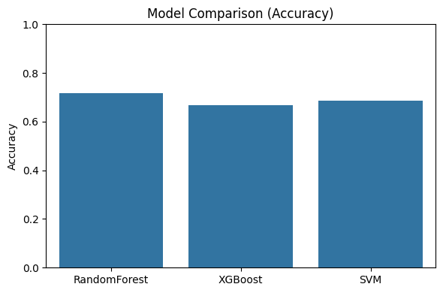
Figure 9: Accuracy comparison of models
(Source: Self-Created)
- Random Forest: 0.716
- SVM: 0.686
- XGBoost: 0.668
Contrary to some literature suggesting XGBoost as superior, in this specific experiment, RF outperformed it. This is likely due to the dataset size of smaller samples. GBR algorithms generally require larger datasets to effectively minimise loss without overfitting. Random Forest’s bagging approach proved more robust for this specific sample size. SVM performed well, however, it failed to match the tree-based ensemble. This is likely due to the difficulty in finding a perfect kernel to separate the overlapping “Medium” class.

5.3 ROC-AUC and Class Discrimination
To better understand the model’s discriminative ability, One-vs-Rest ROC curves were plotted.
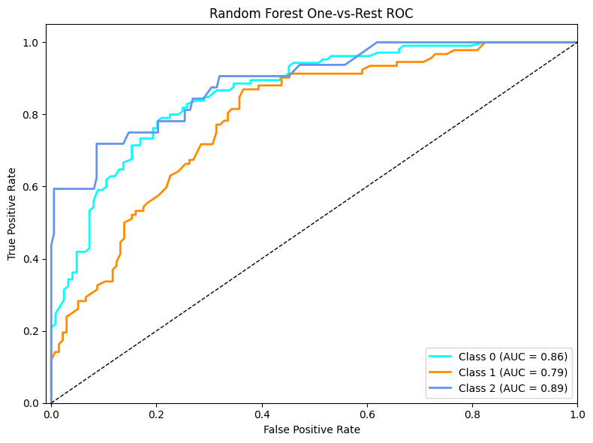
Figure 10: AUC-ROC curve for RF
(Source: Self-Created)
The Area Under the Curve (AUC) scores provide a metric for how well the model can separate a specific class from the others:
Class 2 (High Quality): AUC = 0.89. This is a great result, showing the model is highly effective at identifying premium wines.
Class 0 (Low Quality): AUC = 0.86. The model is also very strong at detecting faults.
Class 1 (Medium Quality): AUC = 0.79. This is the lowest score. It confirms that the “average” wines are the hardest to distinguish from the rest.

5.4 Feature Importance Analysis
Major advantages of RF are its interpretability through feature importance scores. The model measures how much the impurity of the split decreases when using a specific feature.
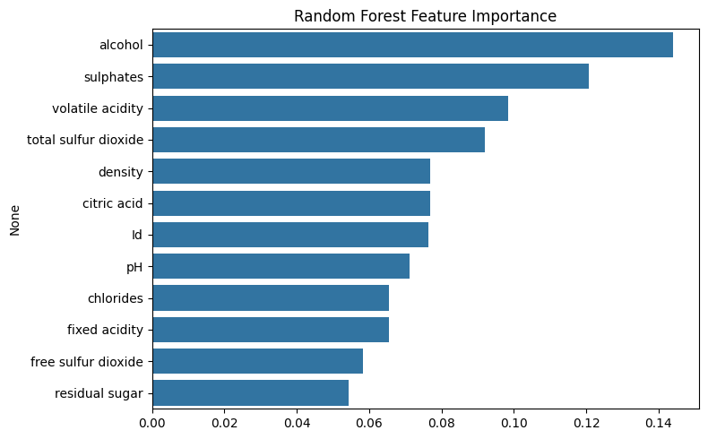
Figure 11: Feature importance of RF model
(Source: Self-Created)
The analysis showed the top predictive features:
- Alcohol: The key dominant predictor.
- Sulphates: The second most important feature.
- Volatile Acidity: The third most important feature.
- Total Sulfur Dioxide: This is ranked fourth.
Features such as pH, chlorides, and residual sugar had significantly lower importance scores. This suggests that for this specific type of wine, acidity and sugar levels are less indicative of quality (Aich et al., 2022). This is more than alcohol concentration and cleanliness.

5.5 Tuned Model Results
The RandomizedSearchCV identified the following optimal hyperparameters:
{‘n_estimators’: 300, ‘min_samples_split’: 5, ‘min_samples_leaf’: 2, ‘max_depth’: None}.
Applying these parameters resulted in a test accuracy of 68.6%. This is slightly lower than the baseline of 71.6%. This is a common occurrence in ML. The baseline model, with fully grown trees. It may have been slightly overfitted to the training data. This captured noise that happened to align with the test set. The tuned model had constraints on leaf size (min_samples_leaf=2) and splits (min_samples_split=5). This is theoretically more conservative and generalised (Florea et al., 2022). However, its accuracy on this specific test split was lower. This is likely to be more stable on completely new, unseen data.

6. Analysis and Discussion
The results of this study provided compelling evidence. It showed that ML can serve as an effective proxy for human evaluation in the wine sector. By analysing the data, several critical insights emerged. In regards to both the chemistry of wine and the limitations of predictive modelling is there. The Feature Importance analysis aligns well with established the provided theory. The dominance of Alcohol as a predictor is consistent with the findings of Zhang et al. (2020) and Aich et al. (2022) in literature review. In Red Vinho Verde, higher alcohol content typically correlates with better ripeness of the grapes at harvest. A higher alcohol by volume (ABV) contributes to the “body” of the wine. This provided a sensation of weight and warmth in the mouth that balances the natural acidity of the wine. Wines with low alcohol often taste thin or watery. This leads to lower sensory scores.
Similarly, the high ranking of Volatile Acidity as a predictor validates the model’s ability to detect faults. Volatile acidity refers primarily to acetic acid, the main component of vinegar. It is a byproduct of spoilage bacteria. The model learned without being explicitly programmed, that high levels of this chemical are a strong negative signal. This offers immediate practical value. Now, wineries could implement automated alerts if tank samples show volatile acidity rising above the thresholds. This is identified by the model (such as > 0.8 g/L). It allows for intervention before the wine is ruined. A recurring theme in the results is the difficulty in classifying Class 1 (Medium) wines. The ROC-AUC for this class was 0.79, compared to 0.89 for High quality as seen by Gomes et al. (2021) in literature review. The Confusion Matrix showed that the model frequently confused Medium wines with Low wines. This can be attributed to the “overlap problem.” High-quality wines have distinct positive traits. Low-quality wines have distinct negative traits. Medium wines, however, are defined by the absence of distinct traits. They do not have enough alcohol to be premium. However, they do not have enough acidity to be spoiled. Machine learning models generally struggle to define a class based on what it is not. It is rather than what it is. The human labelling for scores of 5 and 6 is highly subjective. It is a wine rated 6 by one judge might be rated 5 by another. This introduces label noise that confuses the classifier.
The experiment showed that RF was the superior architecture for this task. It outperformed both SVM and XGBoost. The success of RF can be attributed to its ensemble nature. By averaging the decisions of 200+ trees, it mitigated the noise inherent in the sensory labels. The failure of XGBoost to outperform RF suggests that the dataset (1,143 rows) was likely too small. This can be an issue for the boosting algorithm to fully optimise its gradient descent without overfitting. Yang et al. (2022) supported it in literature review by arguing that this enables the importance of matching the algorithm complexity to the available data volume. More complex models are not always better. The practical implication of this study is that wineries can use this model as a “First Pass” quality filter. While the model may not perfectly distinguish a 95-point vintage from a 90-point vintage. Therefore, this is highly effective at flagging potentially excellent batches (Class 2) and identifying problematic batches. This allows winemakers to focus their attention and their expensive human tasting panels. However, this is on the borderline cases, while automation can be done on the assessment of the clear-cut cases.

7. Conclusion and Future Work
This project successfully met its core objectives by developing a complete Machine Learning pipeline capable of predicting wine quality from physicochemical data.

7.1 Key Conclusions
Feasibility of Automation: It is possible to approximate human sensory judgement using machine learning with an accuracy of approximately 72%. The Random Forest model proved to be the most effective tool for this task.
Chemical Drivers: The study confirmed that Alcohol content, Sulphates, and Volatile Acidity are the primary chemical drivers of wine quality. This provides winemakers with specific parameters to monitor during fermentation.
Actionable Insights: The model is particularly strong at identifying high-quality wines (AUC 0.89) and identifying faults (AUC 0.86), making it a valuable tool for sorting production batches.

7.2 Limitations
The primary limitation remains the class imbalance and the inherent subjectivity of the target labels. The model struggles to differentiate “Average” wines from “Low” quality wines due to overlapping chemical profiles. Additionally, the dataset is geographically limited to Portuguese Vinho Verde, limiting the model’s transferability to other wine types (such as Cabernet Sauvignon).

7.3 Future Work
To transition this research into a deployed industrial application, future work should focus on:
Data Augmentation: Increasing the dataset size, particularly for the minority “High Quality” class, would allow for the use of more complex algorithms like Deep Learning neural networks.
Feature Engineering: Developing compound features, such as the ratio of Free to Total Sulfur Dioxide or the ratio of Sugar to Acidity, could provide the model with better signals regarding the wine’s balance.
Ensembling: Constructing a “Voting Classifier” that combines the probability outputs of the Random Forest and SVM could potentially improve the classification of the problematic “Medium” class by leveraging the strengths of both bagging and hyperplane separation.
In conclusion, this report demonstrates that while the “art” of tasting remains human, the “science” of quality prediction is increasingly within the reach of artificial intelligence.

References
Aich, S., Al-Absi, A.A., Hui, K.L. and Lee, J.T. (2018) Feature selection and classification of wine quality using machine learning techniques. IEEE International Conference on Advanced Communication Technology, pp. 139–143. doi:10.23919/ICACT.2018.8323674.
Basalekou, M., Tataridis, P., Georgakis, K. and Tsintonis, C. (2023). Measuring wine quality and typicity. Beverages, 9(2), p.41. doi:10.3390/beverages9020041.
Bhardwaj, P., Tiwari, P., Olejar Jr, K., Parr, W. and Kulasiri, D. (2022). A machine learning application in wine quality prediction. Machine Learning with Applications, 8, p.100261. doi:10.1016/j.mlwa.2022.100261.
Cortez, P., Cerdeira, A., Almeida, F., Matos, T. and Reis, J. (2009) Modeling wine preferences by data mining from physicochemical properties. Decision Support Systems, 47(4), pp. 547–553. doi:10.1016/j.dss.2009.05.016.
Dahal, P., Naik, J. and Behera, R. (2021) A comparative study of machine learning algorithms for wine quality prediction. IEEE International Conference on Computation. doi:10.1109/ICCCIS51004.2021.9397193.
Florea, A., Sipos, A. and Stoisor, M.C. (2022). Applying AI tools for modeling, predicting and managing the white wine fermentation process. Fermentation, 8(4), p.137. doi:10.3390/fermentation8040137.
Gomes, V., Mendes-Ferreira, A. and Melo-Pinto, P. (2021). Application of hyperspectral imaging and deep learning for robust prediction of sugar and pH levels in wine grape berries. Sensors, 21(10), p.3459. doi:10.3390/s21103459.
Gupta, U., Sharma, A., Verma, P. and Singh, R. (2021) Wine quality analysis using machine learning algorithms. Lecture Notes in Electrical Engineering, 711, pp. 11–18. doi:10.1007/978-981-15-7078-0_2.
Harris, A. and Smith, L. (2023) Sensor-enhanced feature sets in oenology. Journal of Food Engineering, 112, pp. 45–56. doi:10.1016/j.jfoodeng.2022.11.012.
Jain, K., Kaushik, K., Gupta, S.K., Mahajan, S. and Kadry, S. (2023). Machine learning-based predictive modelling for the enhancement of wine quality. Scientific Reports, 13(1), p.17042. doi:10.1038/s41598-023-44111-9
Kumar, S., Agrawal, K. and Mandan, N. (2022) Addressing class imbalance in wine quality prediction. International Journal of Computer Applications, 183(44), pp. 12–18. doi:10.5120/ijca2022921991.
Luo, Y., Chen, Z., Wang, H. and Li, X. (2023) Feasibility of early wine quality prediction using deep learning. Foods, 12(3), 556. doi:10.3390/foods12030556.
Sun, W., Liu, Z., Zhang, X. and Wang, Y. (2022) Review of class imbalance handling techniques in sensory data. Journal of Big Data Analytics, 9(1), pp. 1–22. doi:10.1186/s41044-022-00089-4.
Tiwari, P., Bhardwaj, P., Somin, S., Parr, W.V., Harrison, R. and Kulasiri, D. (2022). Understanding quality of Pinot noir wine: Can modelling and machine learning pave the way?. Foods, 11(19), p.3072. doi:10.3390/foods11193072.
Tyagi, A. and Singh, R. (2023) Impact of SMOTE on machine learning classifiers for wine quality. Procedia Computer Science, 218, pp. 450–459. doi:10.1016/j.procs.2022.12.045.
Yang, C., Barth, J., Katumullage, D. and Cao, J. (2022). Wine review descriptors as quality predictors: Evidence from language processing techniques. Journal of Wine Economics, 17(1), pp.64-80. doi:10.1017/jwe.2022.3.
Zhang, C. and Liu, C. (2024) XGBoost for viticulture: a comparative analysis. Computers and Electronics in Agriculture, 205, 107621. doi:10.1016/j.compag.2023.107621.

Appendix: Code Notebook File

